Pattern and Shape
Resources needed
Fruit
Glue
Magazines or newspapers
Scissors
Piece of paper
Learning objectives – To create and continue patterns using everyday objects. Describes shapes, listing some properties, e.g. sides, round.
- Using fruit make a pattern, start with two types of fruit and then increase. If you make a pattern can they copy it? If you start a pattern can they continue it?
Example
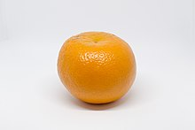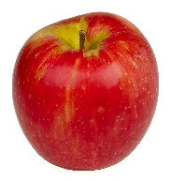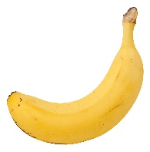

- Play ISPY with my little eye, something that is round, square, straight, long, tall, short.

- Make a shape collage, cut out shapes from an old magazine or newspaper. Sort into all circles, all squares and then make a picture by gluing them to a piece of paper. A house is a good one to make with lots of different sized squares and a triangle for the roof. Or a car with a rectangle and some smaller circles.

- Go on a shape hunt, they could drawer or take pictures of the shapes that they see. Look for street and road signs, traffic cones, trees and flowers.

- Look to the clouds – can you see any shapes, pictures or patterns.

- Sing ‘The Wheels on the bus’ using the hand action for round and round and up and down.

