Strangers and
Safer Strangers
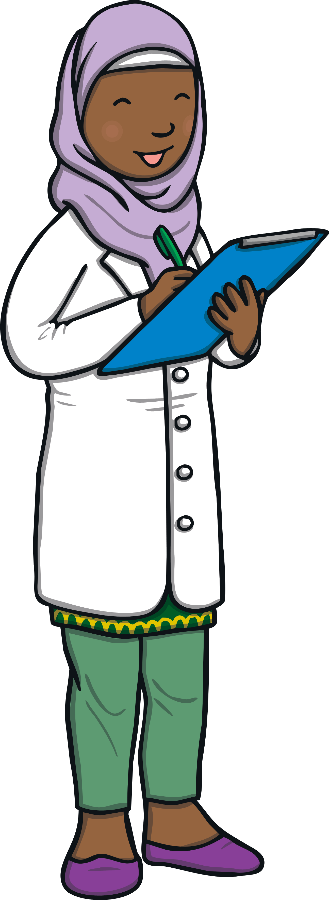
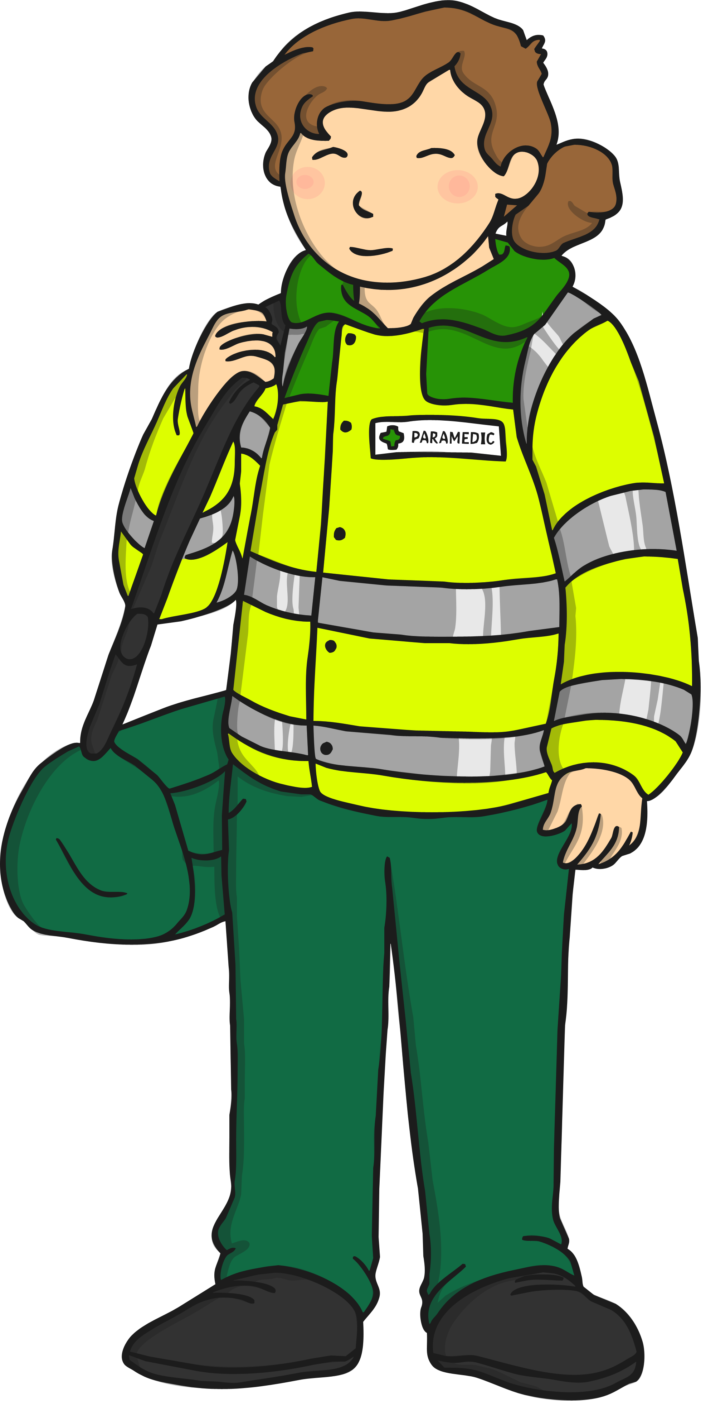
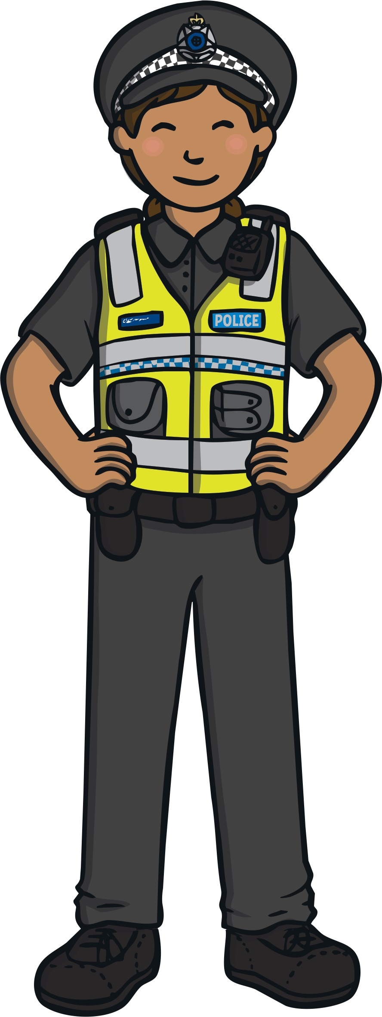
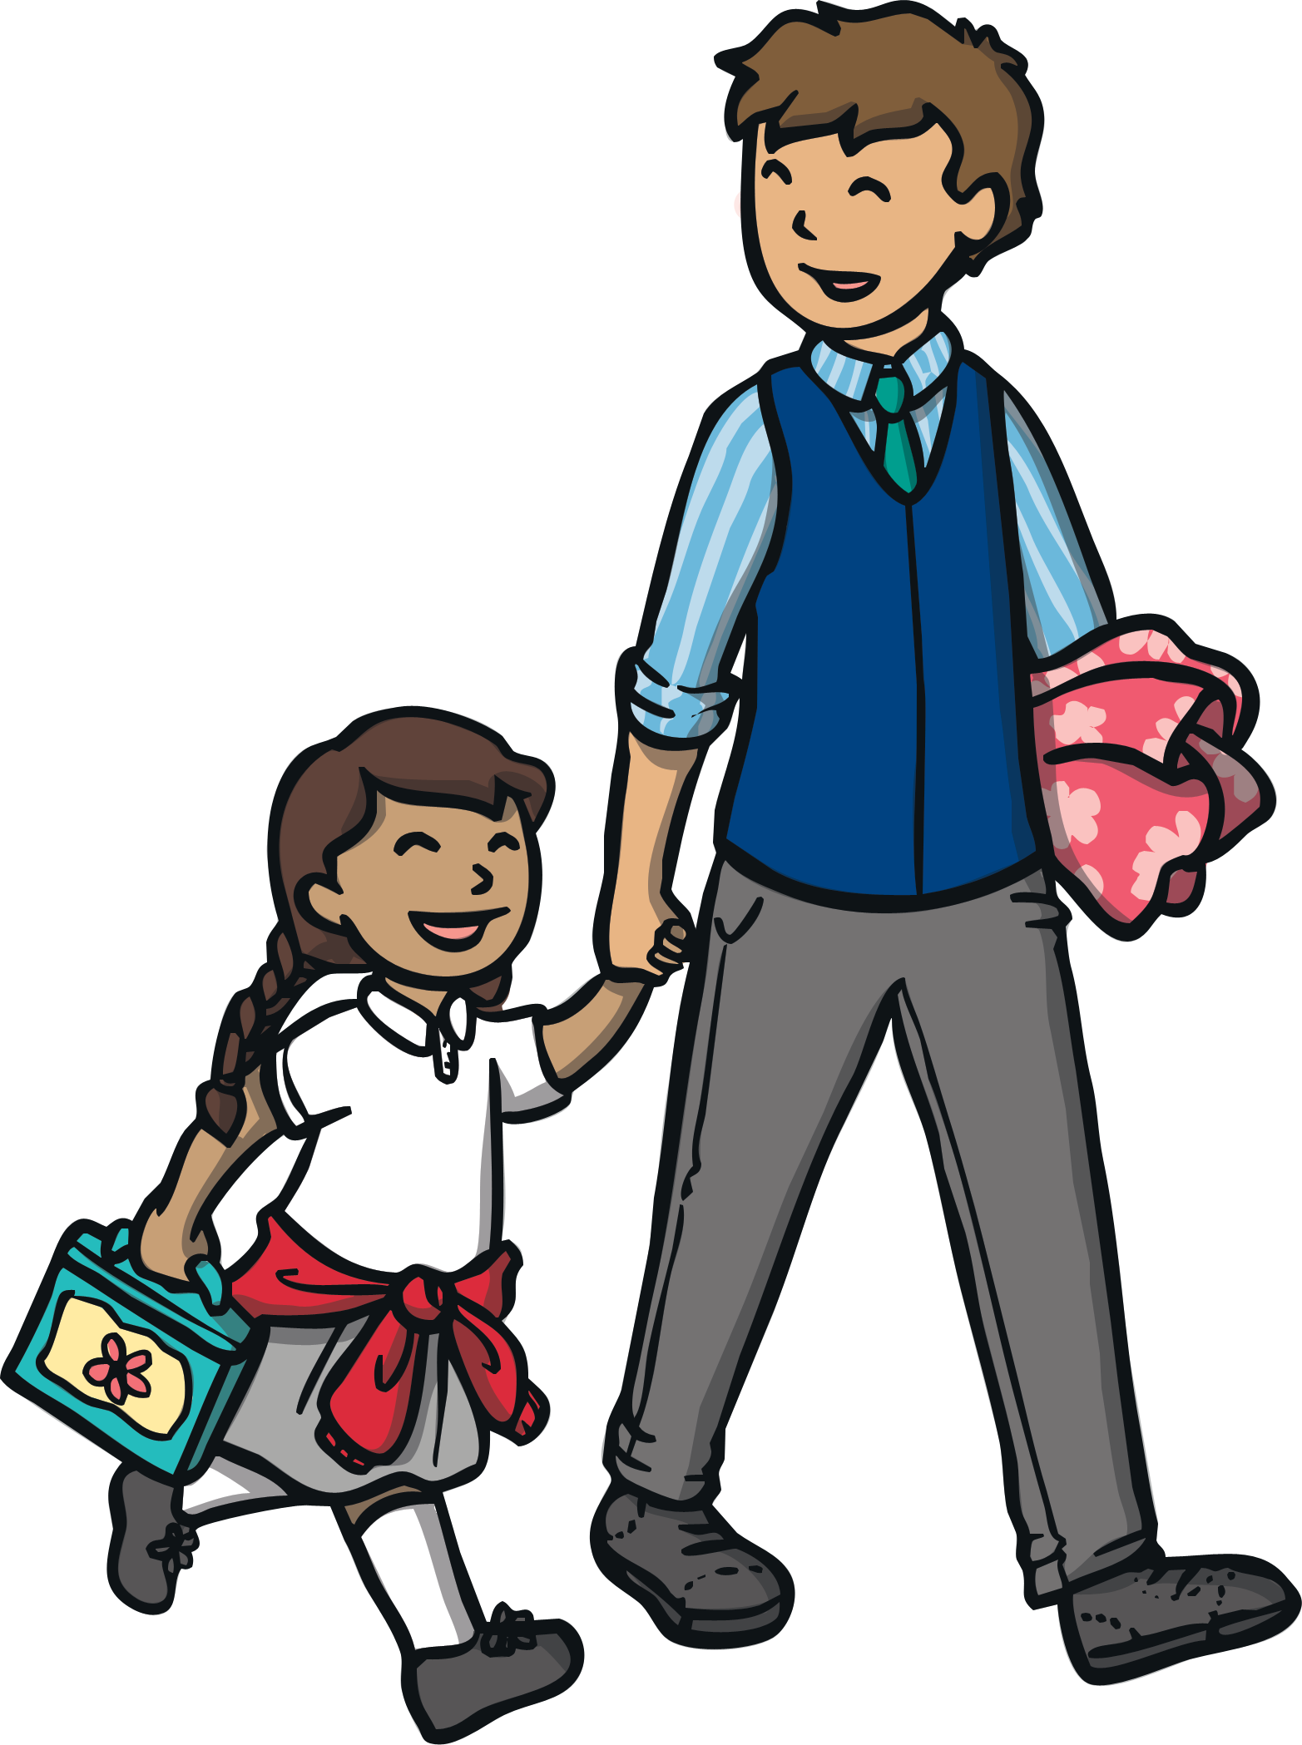
Sometimes we go out.
When we are out, I have to stay with _________________.
When we are out, there are lots of people.
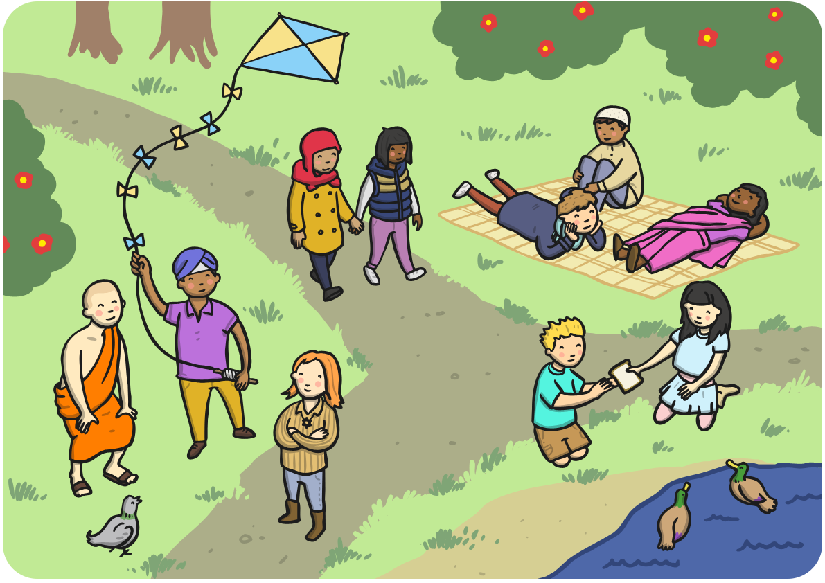
People I don’t know, are called strangers.
Strangers can be nice.

Strangers can be mean.

I shouldn’t talk to strangers.
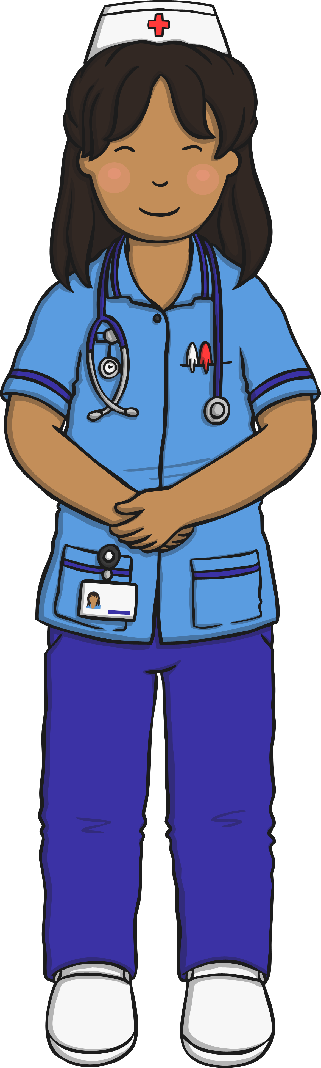
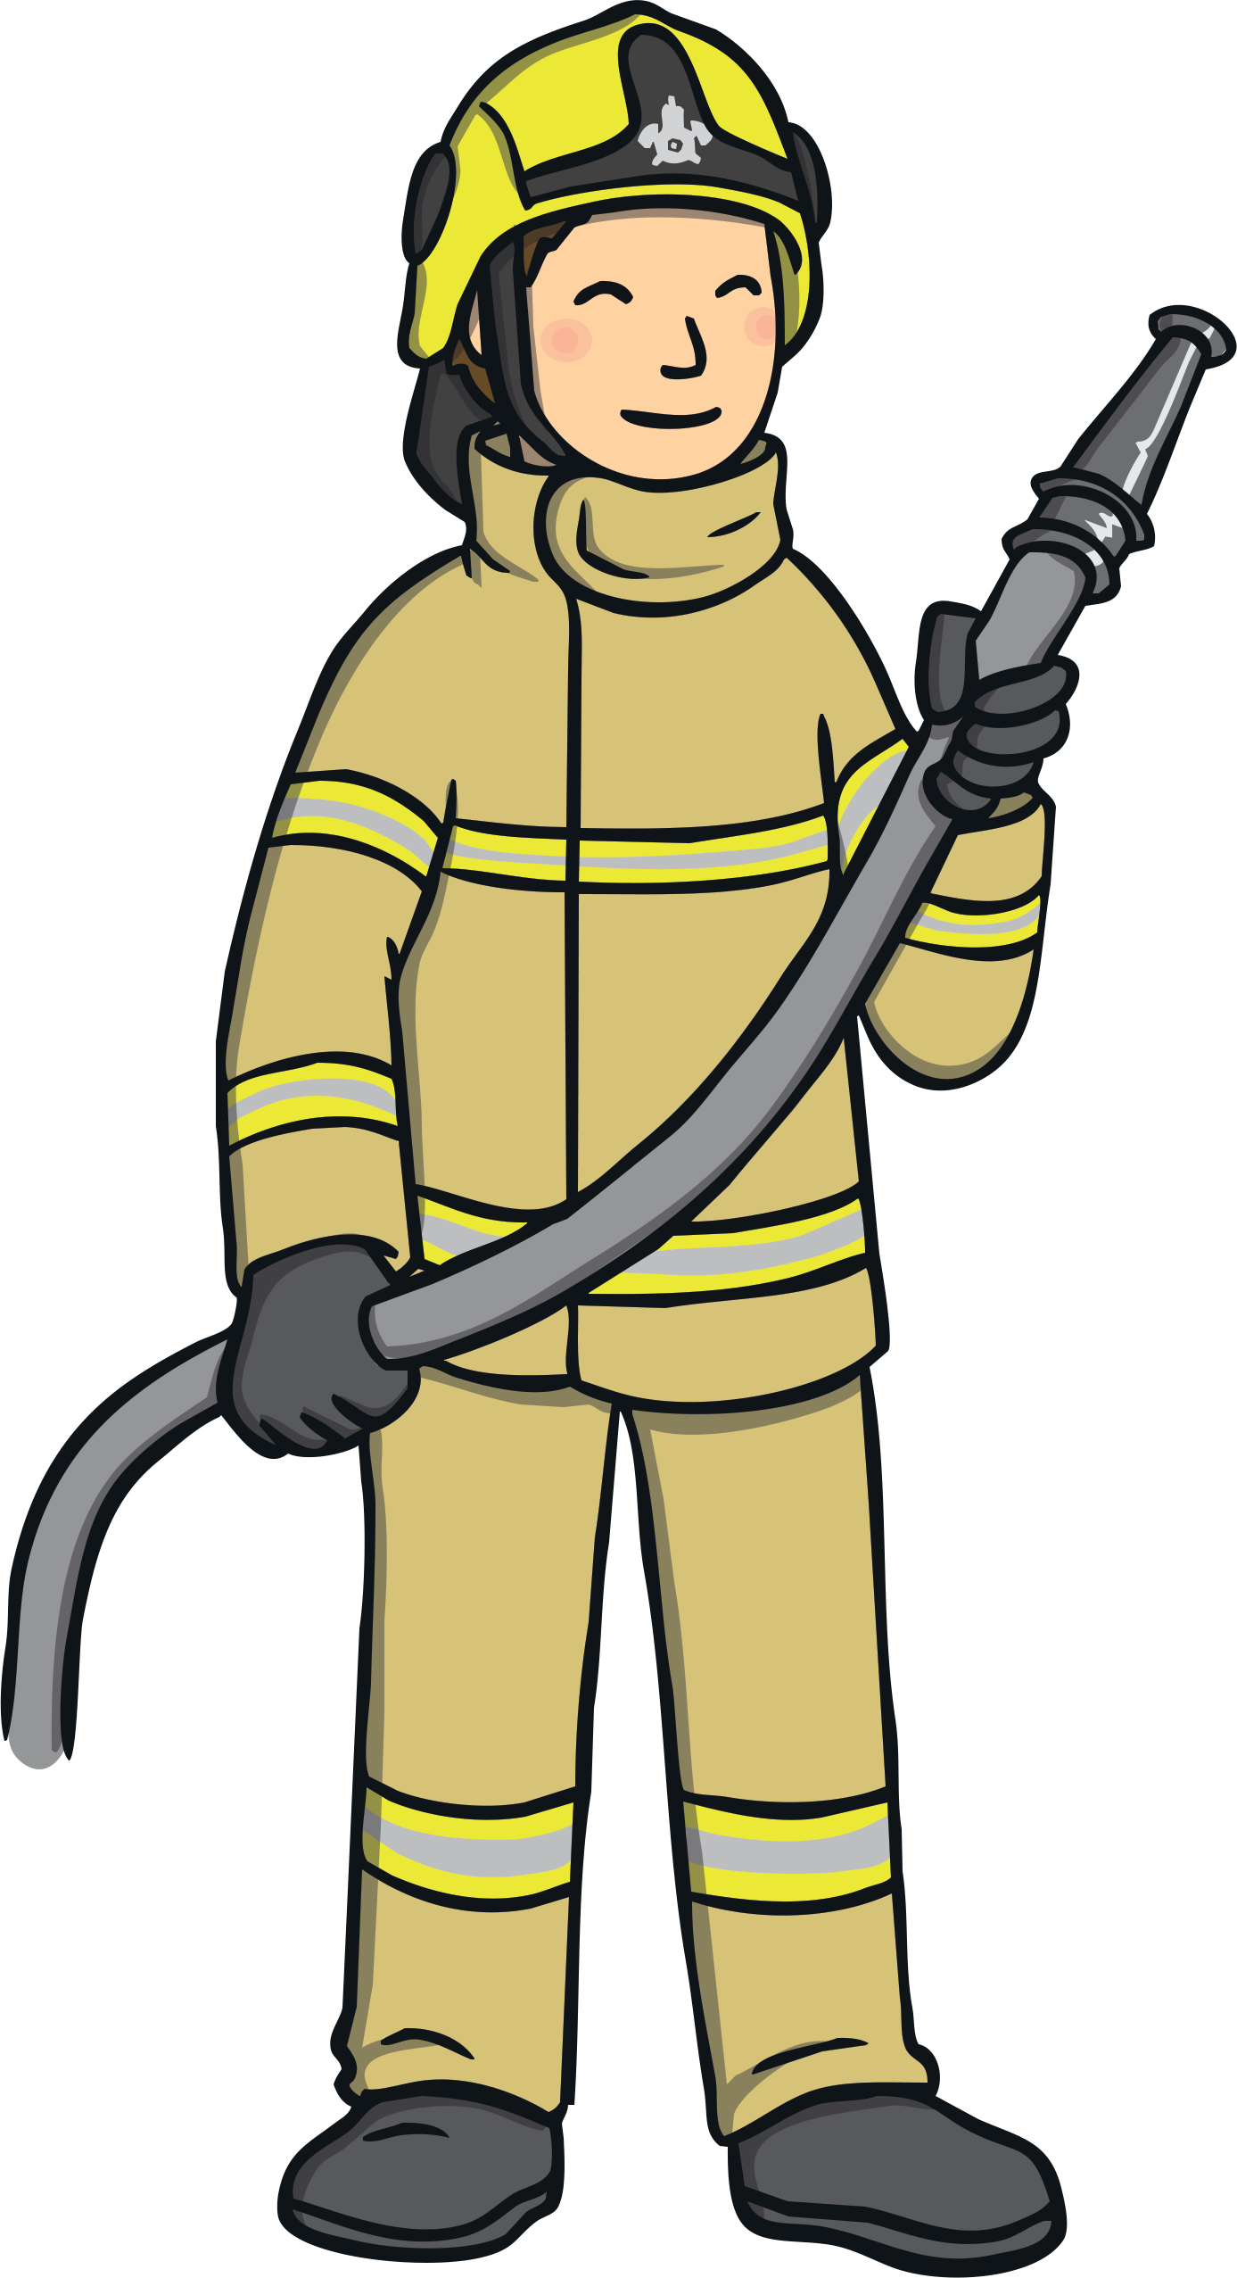
There are some strangers who are ‘safer strangers’.
Safer strangers can help people.
These are people I can talk to.
These are people who will help me if I get lost.
Safer strangers will wear a uniform and a name badge.
If I am lost, I will look for a ‘safer stranger’.
They can help me.

