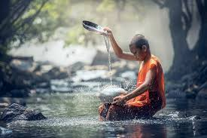
Collective Worship and Wellbeing: BUDDHISM

Learning Objective: To learn about Buddhism and the environment and look after myself and the world.
Buddhism teaches that when we properly care for ourselves we will look after the environment and in doing the best for the world, we benefit ourselves.
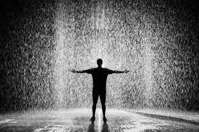
We are thinking about taking care of ourselves at this time as things have been so uncertain and upsetting.

Water and rain are part of the natural world. Perhaps you could spend some time exploring water:- listen to the rain as it falls, either outdoors or at an open window or even on a You Tube video; use water to take care of plants or the grass in your garden; take care of plants in the park by enjoying them but not picking them so they are left to grow; help an insect struggling on its back to turn and move to safety…
Can you relax while exploring water as it is poured from a jug or watering can or play with it in a paddling pool, bath or shower? Can you make bubbles?
At some point today, play the music suggested (https://youtu.be/ABy95341Dto) and let an adult help you to relax, lie down calmly and take time to look after yourself. You could have a foot spa or massage or whatever makes you feel good.
