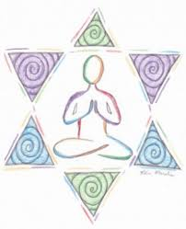
Collective Worship and Wellbeing: JUDAISM

Learning Objective: To learn about Judaism and look after myself in order to be able to look after others
Jewish teachings tell us to take care of ourselves. At the heart of the Torah is the Holiness Code, which tells Jews to “Love your neighbour as yourself.” In order to care for and think of others, Jews must learn to look after themselves first
Self-care is about taking time away from the demands of life to pursue things that make you feel refreshed, renewed and “your best self.”

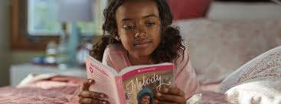
We are thinking about taking care of ourselves at this time as things have been so uncertain and upsetting. Perhaps you could have a walk or ride with family; read a book or have your favourite story read to you; listen to music or have a relaxing massage.
Then perhaps you could do something for someone special to you.. draw a picture for a friend, call someone on the phone or do a video call, give someone a smile or hug or sing and pray together.
If you want to look more into Jewish life and how Jews worship you could look at some videos on You Tube, e.g, Jewish songs for kids at:- https://youtu.be/s_kRKYaqZog
