At Fox Wood School, we use the Read Write Inc (RWI) programme to support pupils to learn to read.

When using RWI to read the children will:

* learn 44 sounds and the corresponding letter/letter groups using simple picture prompts.
* learn to read words using Fred Talk (blending sounds together)
* read stories competently featuring words they have learned to sound out.
* show that they comprehend the stories by answering questions.

When using RWI to write the children will:

* learn to write the letters/letter groups which represent 44 sounds, using a helpful handwriting phrase.
* learn to write words by saying the sounds using ‘Fred Fingers’

**What can you do at home?**When you are teaching your child to read at home, the most important aspect to remember is to use pure phonic sounds when pronouncing the speed sound. There is a video below which will help you with this.

[Parent video: How to say the sounds (youtube.com)](https://www.youtube.com/watch?v=TkXcabDUg7Q)

**Speed Sounds (letter sounds)**

Pupils are taught 3 sets of speed words.   
The children are taught 3 sets of letter sounds.

**Set 1 Speed Sounds**

The sounds are taught in a specific order alongside a memorable rhyme which helps the pupils form the letters correctly. All the speed sounds have graphics attached to them which aids speedy recognition. At Fox Wood School, pupils are taught at their own pace and with lots of repetition and practical activities.

**Set 2 Sounds – Long Vowel Sounds**

Once the pupils are confident with Set 1 Speed Sounds, they move onto Set 2 Sounds – long vowel sounds.

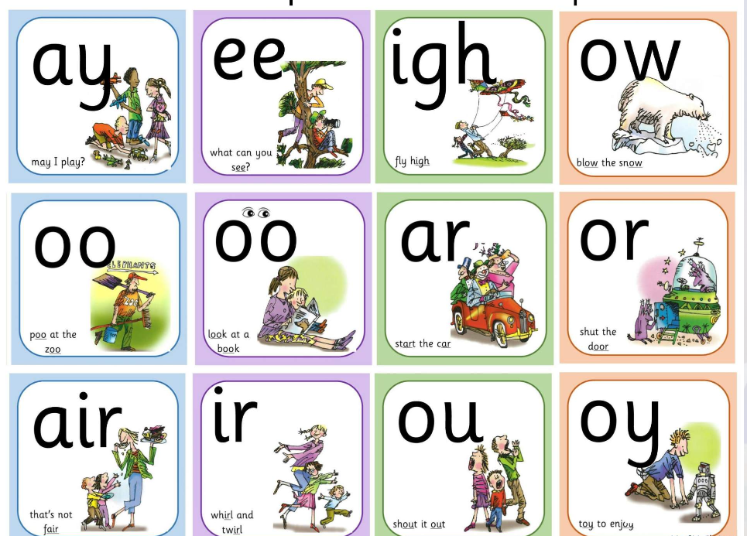

**Set 3 Sounds**

Once pupils are confident with Set 1 and Set 2 sounds they move on to Set 3 sounds.

**Books**  
When pupils are confidently blending, they will be introduced to Sound Blending Books. We will then move pupils onto Ditty Sheets to practice reading simple short sentences.  Once the pupils know all Set 1 sounds, including special friends ‘sh’ ‘ch’ ‘th’ ‘ng’ ‘nk’ and ‘qu’, they will be introduced to Red Ditty books. Pupils will then be assessed regularly to ensure they are moved on to further books as and when appropriate.

Within all the books children will have **red** and **green** words to learn to help them to become speedy readers. **Red** words are words that are not easily decodable and challenge words to extend children’s vocabulary. **Green**words are linked to the sounds they have been learning and are easily decodable.

**Reading at Home**

Below are some links to help support reading at home.

[**http://avanti.org.uk/avantipark/wp-content/uploads/sites/24/2021/04/PAR-RWI-parent-booklet-1.pdf**](http://avanti.org.uk/avantipark/wp-content/uploads/sites/24/2021/04/PAR-RWI-parent-booklet-1.pdf)

[**http://avanti.org.uk/avantipark/wp-content/uploads/sites/24/2021/04/PAR-RWI-parent-booklet-2.pd**](http://avanti.org.uk/avantipark/wp-content/uploads/sites/24/2021/04/PAR-RWI-parent-booklet-2.pdf)

**Green Words**

**Set 1**

**Set 2**

**Set 3**

**Red Words**

**Fred Talk**

We use pure sounds (‘m’ not’ muh’,’s’ not ‘suh’, etc.) so that your child will be able to blend the sounds into words more easily. Fred is our Read Write Inc. friend. He can only speak in sounds, so we help him learn to say words instead of sounds. For example, Fred says ’m-a-t’ instead of mat. We also teach him not to add ‘uh’ to our sounds to keep them pure. For example, we say ’c’ and not ‘cuh.’

**Blending**

Help your child learn to read words by sound-blending (Fred talk) eg. c-a-t = cat, sh-o-p = shop. Children learn to read words by blending the letter-sounds that are in the Speed Sounds set. Help your child to say the pure sounds (‘m’ not ‘muh,’ ‘s’ not ‘suh’ etc.) as quickly as they can, and then blend the sounds together to say the whole word.

 There are lots of further information on RWI on the Ruth Miskin website – some links are below.

<https://www.ruthmiskin.com/parents/>

<https://home.oxfordowl.co.uk/reading/reading-schemes-oxford-levels/read-write-inc-phonics-guide/>

**RWI at Fox Wood School**

RWI has been carefully adapted at Fox Wood to meet the individual needs of the pupils. We encourage pupils to match letter sounds, verbalise (if they can), make the correct shape with their mouth, or identify words beginning with the letter sounds using pictures.

If you wish to talk to anyone at school regarding how specific adaptations are made for you child, please contact your child’s class teacher in the first instance.

Lyndsey Phillips

(English Lead)