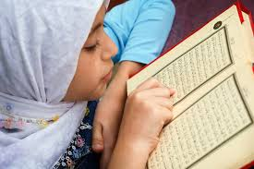
Collective Worship and Wellbeing: ISLAM

Learning Objective: To learn about Muslims’ beliefs about charity and looking after others

Although generosity in giving to others and helping is a natural act of humanity – it is greatly rewarded in Islam, too. Charity is the third of the Five Pillars of Islam (the pillars must be followed by Muslims) – also known as Zakat, which means to give money from what you earn to the poor. There is also the choice to give to the poor, which is Sadaqa.
Many people are in need around the world, especially recently. Could you think of something you could do to help? Fox Wood School often donate to Warrington Food bank and we know how kind all our families are, sending food parcels in, so perhaps this is something you could do with your family? Food Banks are always grateful for donations. You could also make a donation to a charity of your choice such as Save the Children, Epilepsy Action or Cancer Research. If you have clothes and shoes you have grown out of, perhaps you could give them to charity.
Remember though, that charity isn’t always about giving money, but in the words of the Prophet Mohammed: “Your smile for your brother is a charity. Your removal of stones, thorns or bones from the paths of people is a charity. Your guidance of a person who is lost is a charity.”
Charity, for which the expression used in the Holy Qu’ran (Islam Holy Book) is “Spending out of what God has given you” means using your energy, talent, resources, money, possessions or whatever else, to help and do good to those in need.
Giving your time, company, friendship and a listening ear is charity in itself!
Perhaps you could visit a friend or neighbour who cannot leave the house and wave through the window, arrange a video call or make a card for a friend. Sometimes praying together helps or having an online call with someone could brighten up their day! There are lots of ways we can help people in need!
