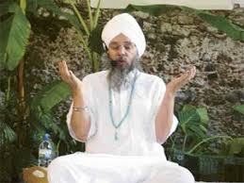
Collective Worship and Wellbeing: SIKHISM
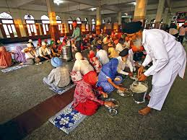

Learning Objective: To learn about Sikh beliefs about community and think how I can be a good member of my community or school.

Sikhs believe that a good life is lived as part of a community, by living honestly and caring for others.
Sikhs focus their lives around their relationship with God, and being a part of the Sikh community. The Sikh ideal combines action and belief. To live a good life a person should do good deeds as well as meditating on God.
Many Sikhs carry out chores in the Gurdwara (their place of worship) as their service to the community. These range from working in the kitchen to cleaning the floor. The Langar, or free food kitchen, is a community act of service.
Sikhs also regard caring for the poor or sick as an important duty of service.

Many people have been poorly lately or feeling sad because they have had to stay indoors and not see people they love. Perhaps you have felt like this? Can you think of something you could do for your community (your family, your neighbours, your school friends, your place of worship) Perhaps you could write a letter or draw a picture for someone who you cannot go to visit and send through the post, maybe you could visit a family member and wave through the window or talk from a distance or sing a song or smile your best smile for a photo or video and email to friends at school who miss you. Maybe you can make a drink or cake for a family member and ask them to watch their favourite programme with you on TV or play a game, or take your dog for a walk? Sometimes praying together helps or having an online call with someone could brighten up their day! There are lots of ways we can help people in our community!

