Humanities:
Geography- Study a region of the UK (not local area) . Use 8 points of compass, symbols & key
History- EQUALS ‘The history of my local area’ NC British History, changes within living memory.
Computing: Digital Painting
NC Collect and present data appropriately
RE: EQUALS- Why is sharing food important on special occasions.
Arts:
Art- Texture- Experiencing and using different textures
NC Learn about great artists, architects & designers

DT- Packaging- experiencing different materials and making their own packaging for something they have made.
NC Use research& criteria to develop products which are fit for purpose

Music- Film songs and sounds
NC Use voice & instruments with increasing accuracy, control and expression
Personal Development:
EQUALS- My independence
Life Skills – Cooking, kitchen safety, oven safety
PSHE: PSHE Association Knowing me- Likes and Dislikes
Focus Subjects:
Arts
Life Skills
Physical Development:
Dance focus
NC Develop flexibility & control in gym, dance & athletics

Sensory Kingdom- different ways to move
Swimming sessions

Science:
EQUALS- Properties and changes of materials NC- Chemistry – Changes of state
Observe that some materials change state when they are heated or cooled

English:
Daily basic skills focusing on Read Write Inc Phonics and reading skill development
Texts: Fiction: Charlie and the Chocolate Factory by Roald Dahl Non- Fiction: Beans to Chocolate by Sarah Ridley Poetry- Chocolate Cake by Michael Rosen
Maths:
Daily basic skills focusing on Number through the Little Big Maths approach
Geometry and Measure- Weight and Volume
Filling containers, heavy and light, empty and full within cooking and baking, sensory materials (Wonka’s factory)
PfA Skills Builder:
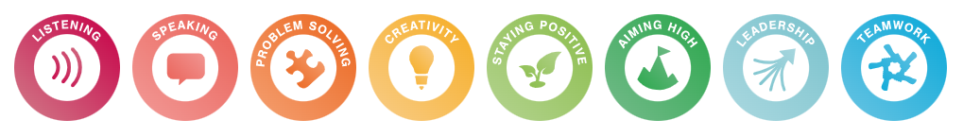

Charlie and the Chocolate Factory
KS2 GREEN AUTUMN
