Sensory Friendly Activities
- SENSORY BIN
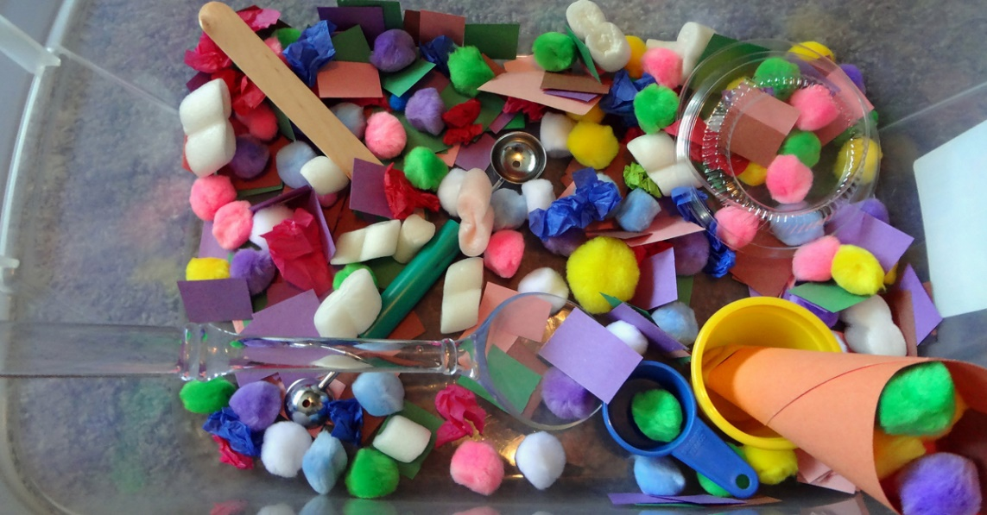

Stimulate the senses of touch and sight with a sensory bin. To make a bin, fill a container with a filler material, such as rice, sand, or shaving cream. Then add in small objects in varying shapes, textures, and colours. Children can dig through the bins with their hands or tongs to work on fine motor skills, colour identification, and object identification.

https://blog.theautismsite.greatergood.com/cs-sensory-activities/

Digging for Spaghetti Worms in Dirt is a simple sensory activity that only takes a few moments to set up. It’s exciting, it’s messy and the kids will have so much fun catching all the slippery and slimy spaghetti worms with tweezers or their fingers and putting them into a jar. This is also good for the children’s fine motor skills, which in turn assists with their writing.
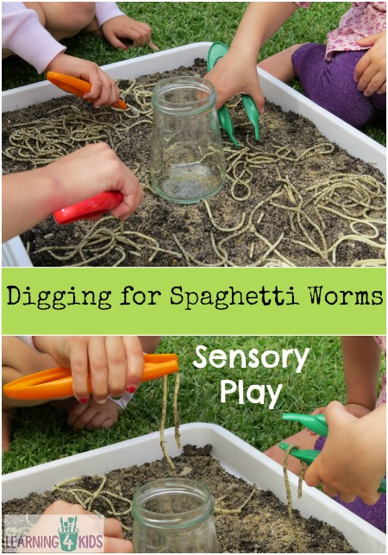
- Use your hands to squeeze, squish and dig out the spaghetti worms from the soil.
- You could also make some edible soil instead using crushed biscuits (oreos) etc.
- Use the tweezers to catch the worms and place them into a container.
- Count out loud as each worm is caught and placed into the jar.
- Measure the different lengths of the worms such as “this worm is the longest” or “this worm is shorter than the last one”.

Easy Sensory Play – Shaving Cream and Bubble Wrap
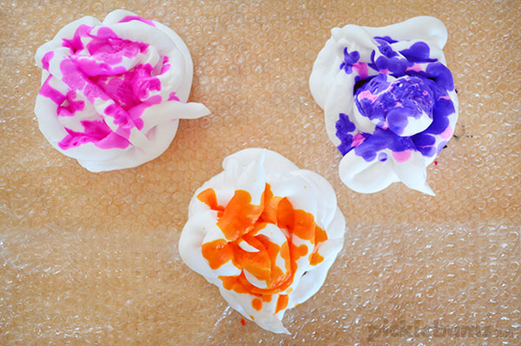

You’ll Need:
- a table or area on the floor
- bubble wrap
- shaving cream
- tape – optional but recommended
- paint, liquid water colours, or food colouring – optional but fun
- a smock, apron, or naked child!
Tape the bubble wrap to the table or floor to stop it moving around. The bubble wrap adds and extra sensory dimension to this activity. Squirt some shaving cream onto the bubble wrap and add a few squirts of colour or dollops of paint if you like. Adding colour will up the mess factor slightly, and be aware that some food colouring can stain. We used liquid water colours which add a bright vivid colour and clean up really easily. Pop on a smock or go shirt-less, be careful not to get the shaving cream in their eyes… and then let them go to town!

