Sometimes we go out.

When we are out, I have to stay with ______________________.

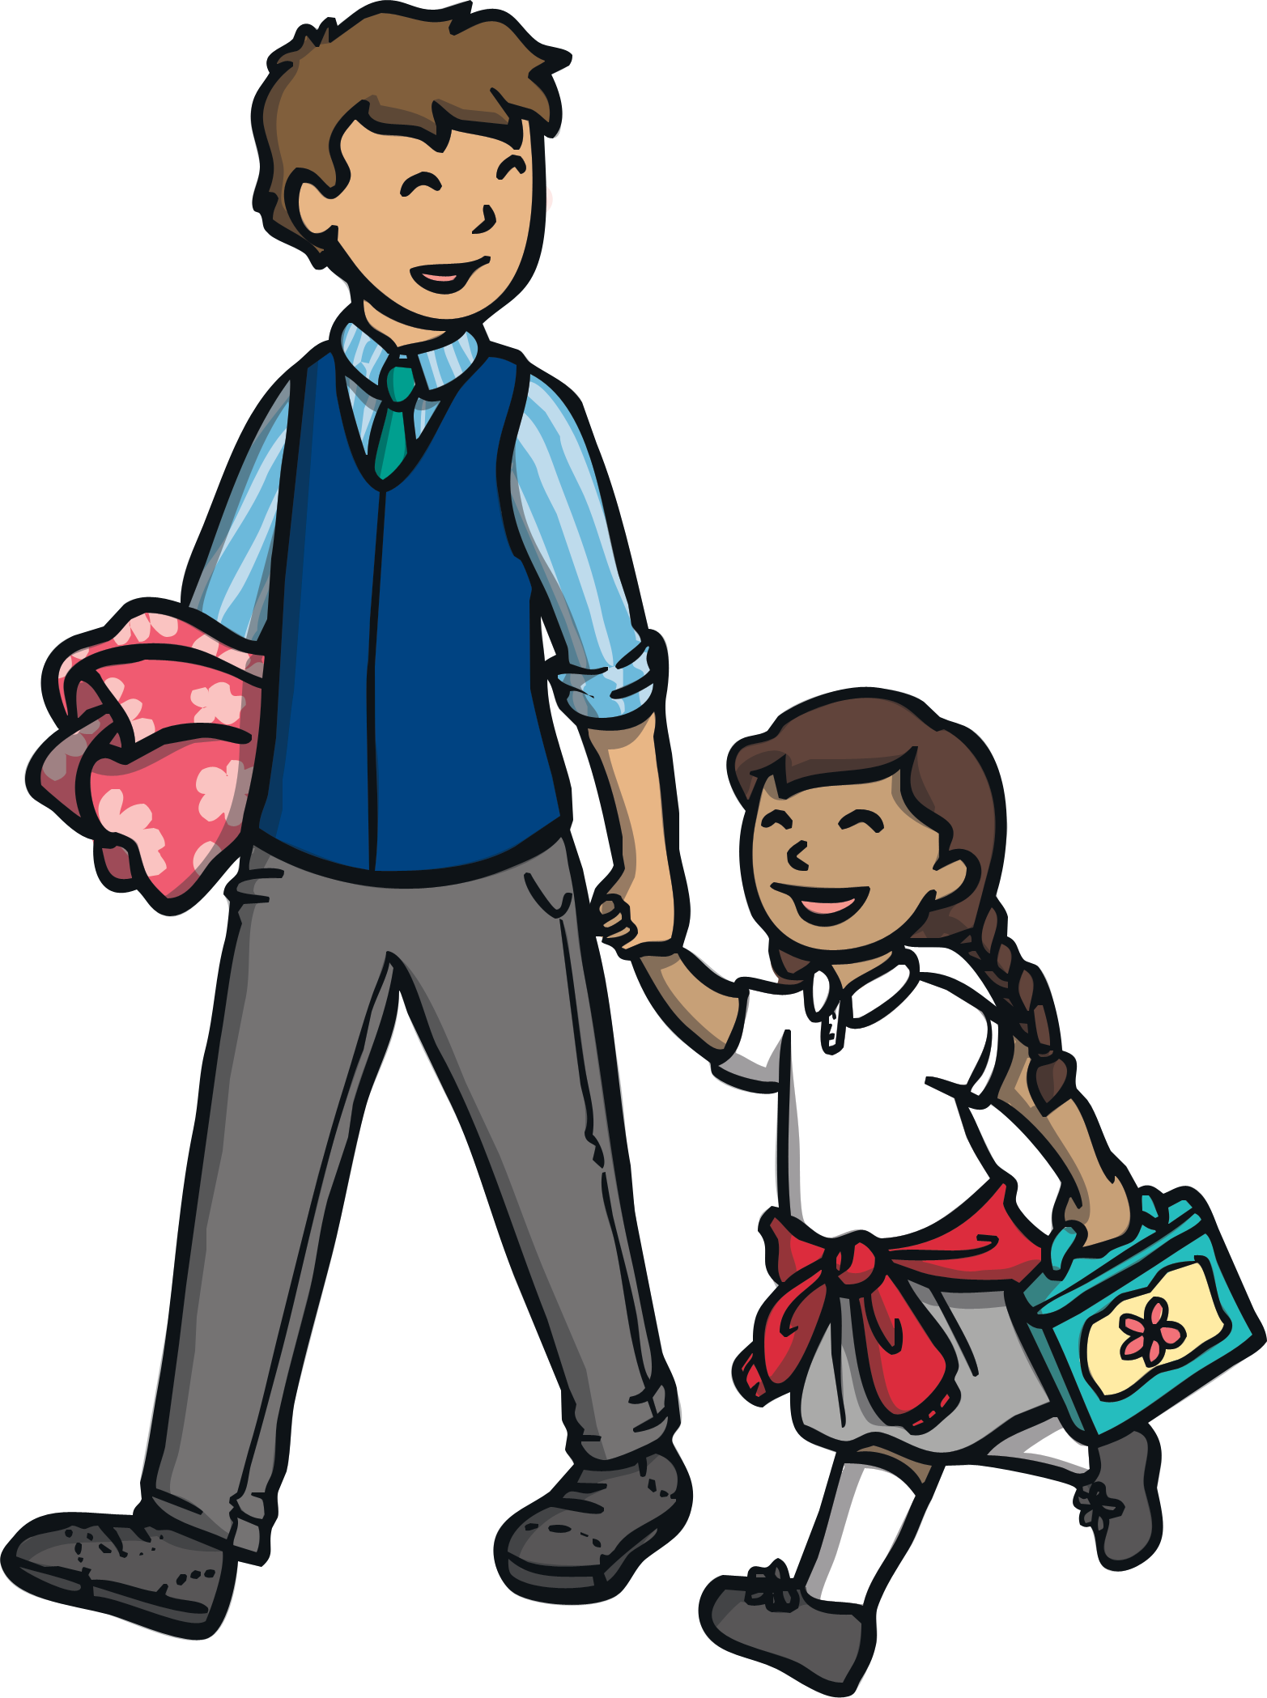

When we are out,
there are lots of people.
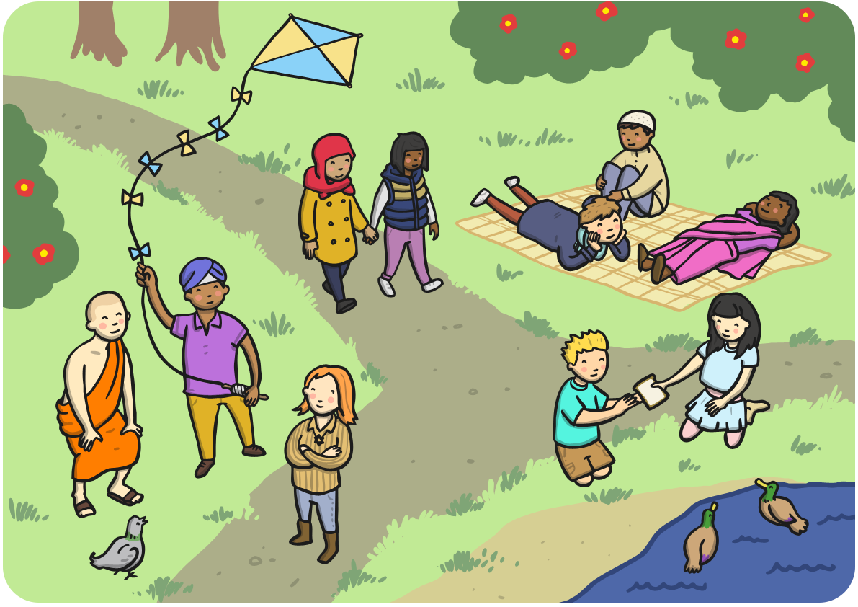

People I don’t know,
are called strangers.

Strangers can be nice.



Strangers can be mean.


I shouldn’t talk to strangers.

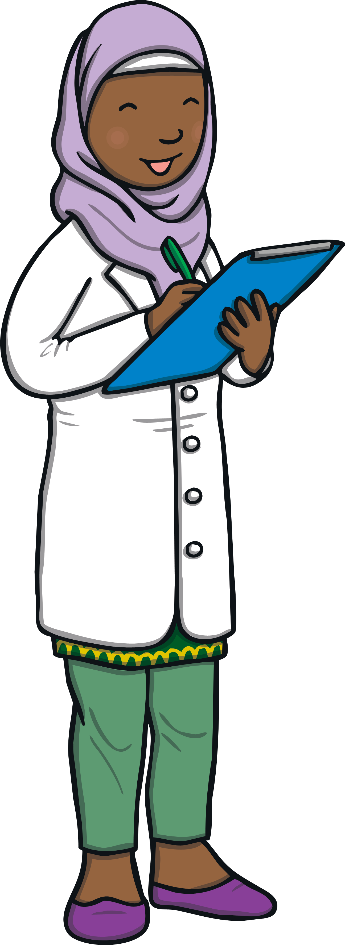
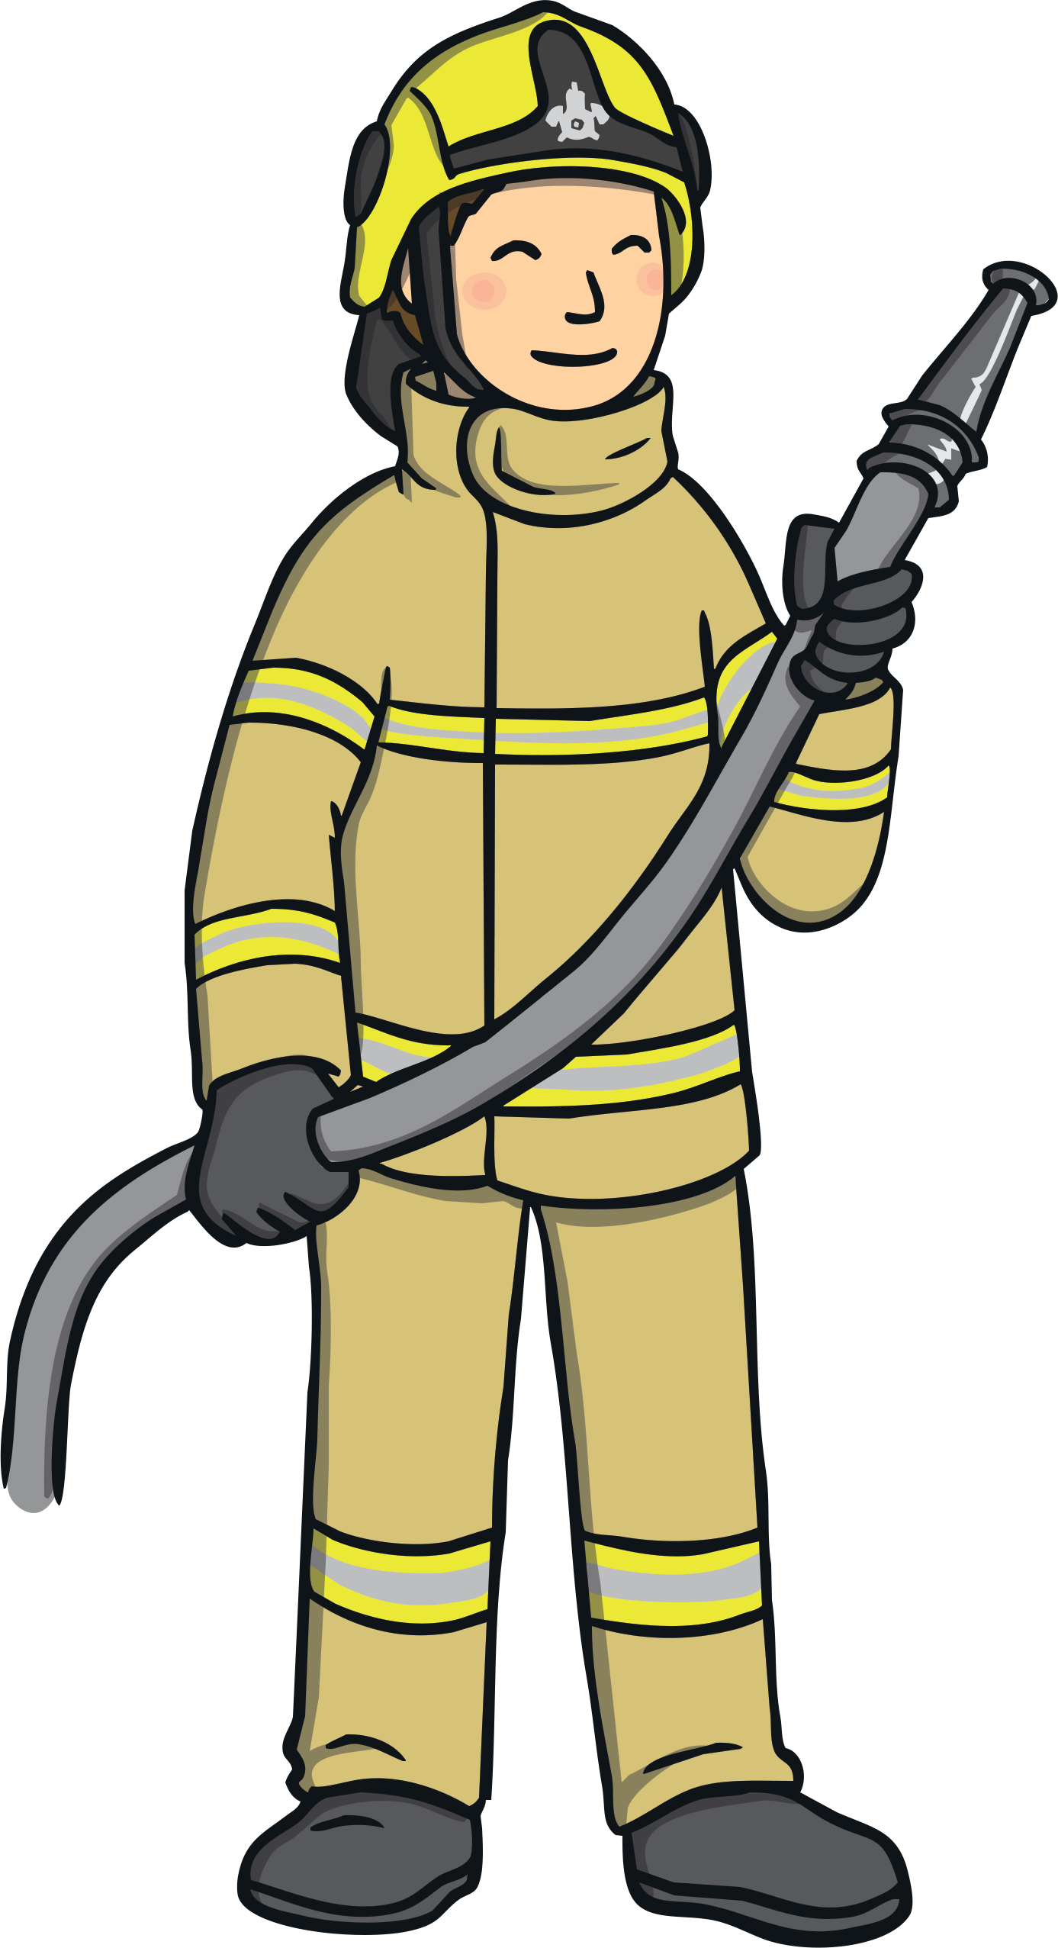
There are some strangers who are ‘safer strangers’.
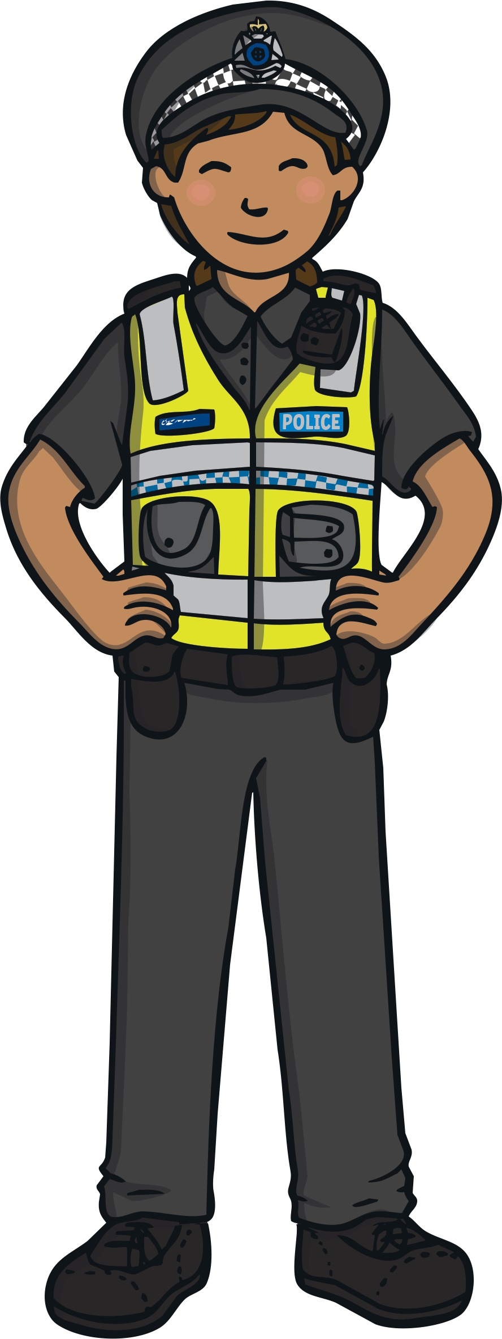
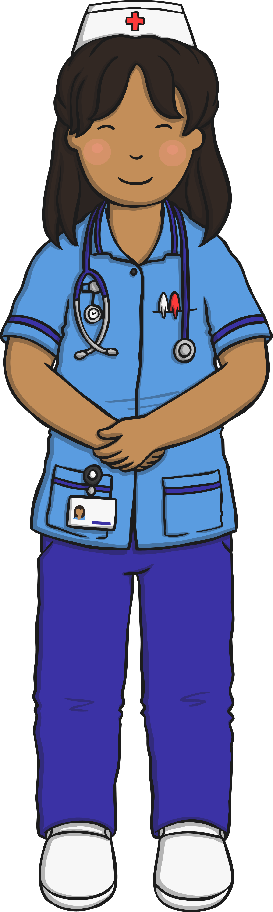
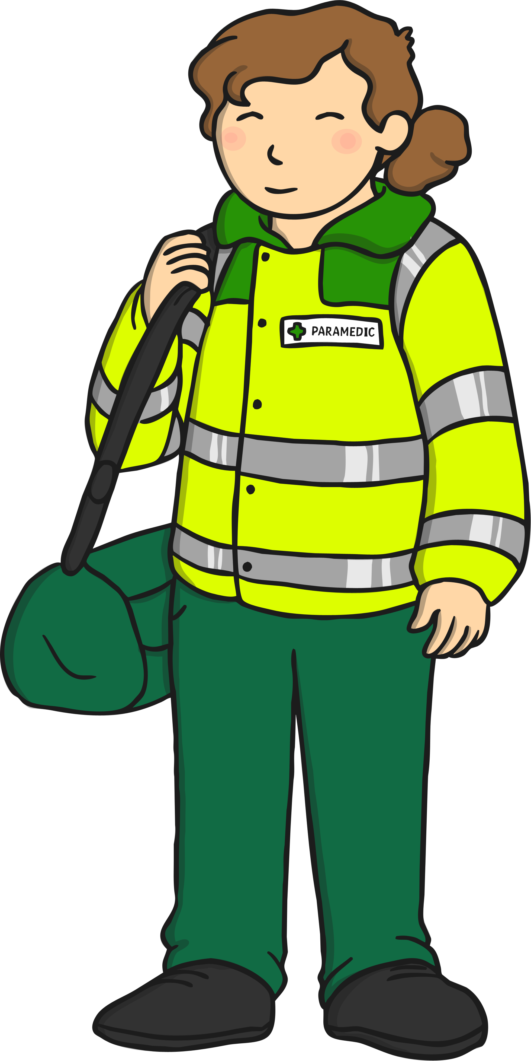

Safer strangers can help people.

These are people I can talk to.

These are people who will help me if I get lost.

Safer strangers will wear a
uniform and a name badge.

If I am lost, I will look for a
‘safer stranger’.

They can help me.

