Sensory calming activity’s
Sensory calming activities are great to pass the time making and also useful once made, if your child can sometimes become excited or anxious then playing and watching some of the activities below can be very beneficial.
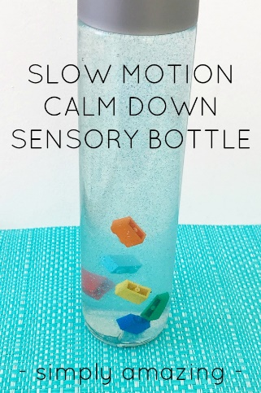https://childhood101.com/calm-down-bottle/
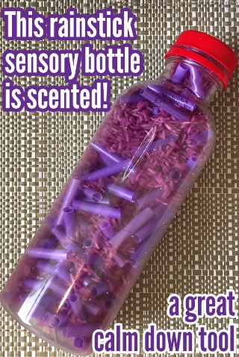https://childhood101.com/scented-rainstick-sensory-bottle/

